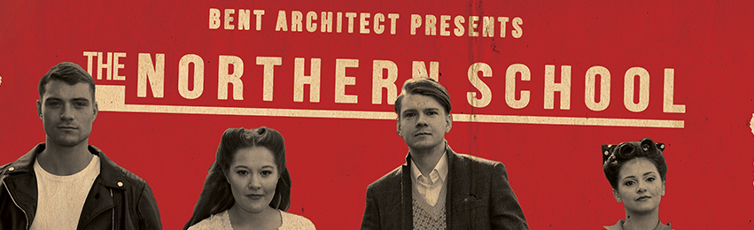

PRESS RELEASE
An exciting new show which uncovers Bradford's untold cultural legacy.
Mick Martin & Jude Wright are bringing together a team of actors and artists to transform the Bradford Playhouse and take it back in time to the 1950's. The Northern School show will take place from Tuesday 4 to Saturday 8 October at the Bradford Playhouse.
With funding from Arts Council England, they will tell the untold story of Esme Church and the drama school she founded there which launched the careers of some of the biggest theatre stars of the last 50 years.
The piece will be performed by a professional and community cast and features a live rock 'n' roll band, dance and film. Set in the very place where Church's Northern School of Acting was based, the company plan to take over the whole building in a site specific performance. Audiences will be able to explore the Bradford Playhouse theatre backstage and behind the scenes, discovering performances and happenings across the site.
Mick Martin, Bradford-born and based writer and director, says:
"We aim to create something more than a play. It has elements of a film and a nightclub all rolled into one. We want it to be a theatrical adventure right through the building."
Martin is renowned for his comic writing and has written work for the West Yorkshire Playhouse, Hull Truck, and the Bolton Octagon, to name but a few, as well as television and radio. The show promises to have all his hallmarks of quick wit and observational comedy.
Jude Wright, Bradford-based director, says:
"We wanted to do something which was absolutely about Bradford, which celebrates our rich past and our growing confidence in our cultural future. The show will be eclectic and fun - a really fantastic night out and unlike anything you've seen before."
The story tells of a group of young hopefuls who join the Northern School hoping to take to the stage. But the 60’s are looming, and the British New Wave is ready to explode. Unbeknown to Miss Church, they no longer want to look and sound like the old school - Laurence Olivier and Vivienne Leigh. They want to see and hear about their own lives with all the dramas. A seismic clash of culture is about to unfold when the real drama happens backstage and the students rebel.
The production is supported by the Arts Council, Bradford Council, Theatre in the Mill, The National Media Museum and Bradford College, as the company wanted to draw on the rich variety of culture that Bradford has to offer.
In partnership with the Media Museum, free screenings of films which inspired the production will also take place at community venues across the district, as part of the company's outreach work. These will be at Bolton Woods Community Centre (8 Sept, 6.30pm), Bierley Life Centre (13 Sept, 6.30pm), Karmand Centre (14 Sept, 2pm) and Keighley Central Hall (16 Sept, 7pm).
The show will run from Tuesday 4 to Saturday 8 October at 7.30pm with a 2.30pm matinee on Saturday. Tickets for the show are £12/£10 concessions available now from the Bradford Playhouse website: www.bradfordplayhouse.org.uk or by calling 01274 800415.
More information about the show and the film screenings can be found on the company's website at www.bentarchitect.co.uk.
ENDS
Editors Notes
- Based in Bradford, Mick Martin & Jude Wright have been working together as Bent Architect since 2007. They produce new work in theatres and non theatre spaces that aims to engage audiences with stories that inspire as well as entertain.

- The creative team includes Barnsley-based choreographer Gary Clarke. Winner of the 1998 Brian Glover Memorial Award, he is currently regarded as one of the UK’s leading contemporary dance artists and his current production of COAL is touring this year. Find out more on the COAL Website.

- The professional cast includes Ben Burman (Northern Broadsides, Emmerdale), Meriel Scholfield (Hull Truck, Library Theatre), Jim English (Shakespeare's Globe, Red Ladder), Natalie Davies who has recently been seen as seen as Bethany's bully, Shelley, in Coronation Street and Claire-Marie Seddon (Royal Lyceum, Pitlochry Festival).

- Live music will be provided by Leeds-based rock 'n' roll band, the Hail Bails. They include ex-members of the Folk Theatre Partisans, the Lodger and the Lovesick Cowboys.

- Sound designer Ivan Mack is based in Bradford and is a freelance light and sound designer, musician, photographer and film-maker. He also works at Theatre in the Mill. Recent work has included musical collaboration (as part of The Housekeeping Society) with the 154 Collective and A Firm of Poets, both of which have a large emphasis of placing art into the wider non-arts world.

- The production has been generously supported using public funding by the National Lottery through an Arts Council England Grants for the Arts award of £49,948.
For more information, please contact Jude Wright on 07968 165 744 or jude.producer@gmail.com

